SOFTWARE PROJECT MANAGEMENT

INVENTORY MANAGEMENT SYSTEM (IMS)

COMPLETE
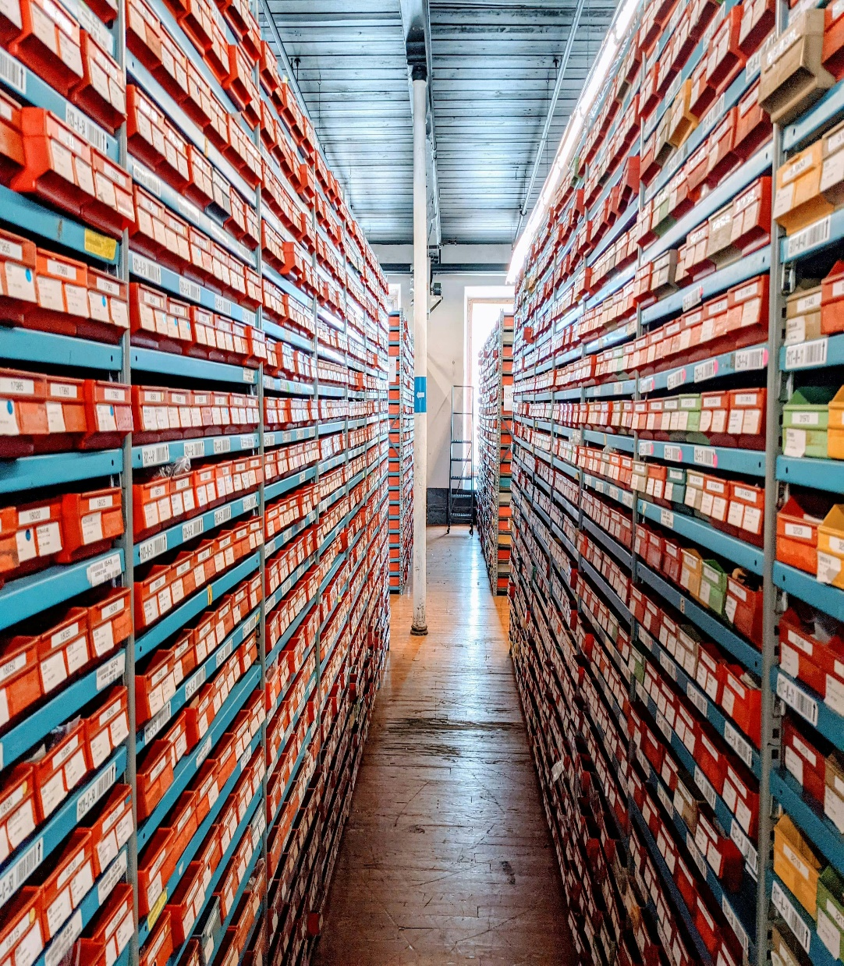
Group Members:
- MUTANGANA Joseph 29061
- Musangwa Nshimiye Bennett 29092
- Nshimyumuremyi Elie 26476
- Shema Abdunur 28334
Contents

Inventory Management System (IMS) 2
Needs Assessment & Business Case 2
Identifying and Engaging Stakeholders 5
Forming The Team 6
RACI Chart 7
TEAM CHARTER 7
GROUND RULES 8
PROJECT SCOPE MANAGEMENT 9
REQUIREMENTS 9
MoSCoW PRIORITIZATION 11
ACCEPTANCE CRITERIA 11
DELIVERABLES 12
OUT OF SCOPE 12
CONSTRAINTS 12
ASSUMPTIONS 12
Working Breakdown Structure & Work Packages 12
Working Breakdown Dictionary 13
Activity Dependencies 15
Time Estimation 15
Resource Calendar 17
Risks 18
Negative Risks 18
Positive Risks 18

Inventory Management System (IMS)

Needs Assessment & Business Case

- Introduction / Background: The Inventory Management System (IMS) project is planned to fix problems in how businesses manage stock, track products, and keep inventory records. Many companies still use manual methods or separate systems, which can cause mistakes, delays, and higher costs. IMS will give a single, reliable solution for managing inventory.
- Business Goals
- Make inventory records more accurate
- Reduce stock shortages and extra stock
- Improve work efficiency
- Help make better decisions with up-to-date inventory information

- Current Situation and problem/opportunity statement: Tracking inventory is slow and often has mistakes because records are kept by hand and not updated in real time. This is a chance to create an automated system that saves time, reduces losses, and makes customers happier.
- Critical Assumptions and Constraints
- Users know basic computer skills
- Necessary computers and internet are available
- Management supports the project
Limits(Constraints):
- Small project budget
- Fixed timeline
-Small development team

- Analysis Options and Recommendation

- Option 1: Keep using manual inventory (cheap but risky)
- Option 2: Buy ready-made software (medium cost, less flexible)
- Option 3: Build a custom IMS (more work, best fit)
Recommendation: Option 3 is recommended because it meets the business needs and can be customized.
- Preliminary Project Requirements

- Manage products and stock
- Record stock coming in and going out
- Send alerts for low stock
- Provide simple reports

- Budget Estimate: The estimated cost covers software development, testing, and launching the system. The cost is moderate, good for a small-to-medium project.
- Timeline Estimate: The project should take about 3–4 months, including analysis, design, development, testing, and launch.
Project Timeline (3-4 Months)

Month 1 – Planning & Requirements
- Project Charter
- Stakeholder Identification
- Requirements Gathering & Approval

Month 2 – System Design
- System Architecture
- Database Design
- UI/UX Design

Month 3 – Development
- Inventory Module
- User Management
- Alerts & Reports

Month 4 – Testing, Deployment & Training
- Unit Testing
- System Testing
- User Acceptance Testing
- Deployment
- User Training
- Project Closure

- Possible Risks
- Users may resist changes
- Delays in the schedule
- Requirements might not be clear

10.Exhibits
System Over View

Identifying and Engaging Stakeholders

11.Stakeholder Register

Stakeholder Name | Contact Information | Project Role | Project Requirements | Project Concerns | Influence
MUTANGANA Joseph | +900 588 123 456  josephm@gmail.com | Project Sponsor | System delivered on time and within budget | Cost overruns, delays | Supportive
MUSANGWA Nhsimiye Bennet | +901 722 456 7  bennet@gmail.com | Project Manager | Clear scope, smooth execution | Schedule delays | Supportive
Nshimyumuremyi Ellie | +902 733 987 6  ellie@gmail.com | Inventory Manager | Accurate stock tracking, expiry alerts | Incorrect stock data | Supportive
Shema Abdnur | abdnur@ims.com | Development Team | Clear requirements | Changing requirements | Supportive
Beata Mukamana | +904 729 111 2  bmkana@gmail.com | Procurement Officer | Low-stock alerts, reorder reports | Late purchase decisions | Supportive
Eric Bizimana | 0783 444 555  ebizi@gmail.com | Finance Officer | Correct inventory valuation reports | Inaccurate costing | Neutral
Samuel Karegeya | 5730 999 888  skare@gmail.com | IT Administrator | Secure system, backups | Data loss, system failure | Neutral
Jean Claude | claudej@ims.com | Senior Manger | Project aligns with company goals | Cost, Risk | Supportive

- Stakeholder Mapping

 | High Interest | Low Interest
High Power | Project Sponsor, Project Manager | Senior Management
Low Power | Inventory Manager ,Store Staff , Procurement Officer, Development Team | Finance Officer, IT Administrator

Forming The Team

Team members
Name | Role
MUTANGANA Joseph | Project Sponsor
MUSABWA Nshimiye Bennet | Project Manager
Nshimyumuremyi Ellie | Business Analyst
Shema Abdnur | Lead Developer
Brian | Software Developer
Grace | UI Designer
Michael | Quality Assurance

RACI Chart

Activity | Project Sponsor | Project Manager | Business Analyst | Lead Dev | Soft Dev | UI | QA
Develop Project Charter | I | A | C | I | I | I | I
Define Project Scope | I | A | R | C | I | I | I
Gather Requirements | I | A | R | C | I | I | I
Approve Requirements | I | R | C | I | I | I | I
System Architecture Design | I | I | C | A | C | I | I
UI/UX Design | I | I | C | C | I | A | I
System Development | I | I | C | A | R | I | I
8. System Testing |  | I | C | C | I | I | A
9. User Acceptance Testing | I | A | R | I | I | I | C
10. Deployment & Project Closure | I | A | C | C | I | I | C

R = Responsible A = Accountable C = Consult I = Informed

TEAM CHARTER

Team Purpose
The purpose of this team is to successfully design, develop, test, and deploy an Inventory Management System (IMS) that improves stock tracking accuracy, reduces shortages and excess inventory, and enhances operational efficiency.

Team Objectives
- Deliver a functional IMS within the approved timeline
- Meet all defined requirements
- Ensure system reliability and usability
- Maintain effective communication among team members
- Deliver quality documentation

Roles and Responsibilities
- Project Manager – Oversees planning, scheduling, risk management, stakeholder communication.
- Business Analyst – Gathers, documents, and validates requirements.
- Lead Developer – Designs system architecture and supervises development.
- Software Developer – Implements system features.
- UI/UX Designer – Designs system interface and user experience.
- QA/Test Engineer – Conducts testing and ensures system quality.

Communication Plan
- Weekly team meeting (every Monday)
- Progress updates via email or WhatsApp group
- Urgent issues communicated immediately
- Formal reports submitted to Project Sponsor bi-weekly
Decision-Making Approach
- Technical decisions → Led by Lead Developer
- Requirement decisions → Led by Business Analyst
- Strategic decisions → Approved by Project Manager
- Major changes → Approved by Project Sponsor

Conflict Resolution
- Issues discussed internally first
- If unresolved → Escalated to Project Manager
- If still unresolved → Sponsor intervention

GROUND RULES
- All members must attend scheduled meetings.
- Deadlines must be respected.
- Members must communicate blockers within 24 hours.
- Respect all team members’ opinions.
- No task reassignment without PM approval.
- Documentation must be updated regularly.
- All work must follow agreed quality standards.

PROJECT SCOPE MANAGEMENT
The Inventory Management System (IMS) will include the following features:
- User authentication and role-based access
- Add new inventory items
- Update item quantities
- Delete items
- Automatic low-stock alerts
- Supplier management module
- Purchase order tracking
- Inventory reporting
- Dashboard overview
- Stock history logs
- Export reports (PDF/Excel)
- User management
- Audit trail
- Data backup functionality

REQUIREMENTS

FR= Functional Requirement NFR= Non-Functional Requirement
BR=Business Requirement TR= Technical Requirement

Req ID | Requirement Description | Type | Source | Priority | Test Case ID | Status
FR1 | The system shall allow users to log in securely. | Functional | Project Sponsor | Must | TC01 | Planned
FR2 | The system shall allow authorized users to add new inventory items. | Functional | Inventory Manager | Must | TC02 | Planned
F  R3 | The system shall allow updating item quantities. | Functional | Inventory Manager | Must | TC03 | Planned
FR4 | The system shall allow deletion of obsolete items. | Functional | Inventory Manager | Must | TC04 | Planned
FR5 | The system shall generate low-stock alerts. | Functional | Inventory Manager | Must | TC05 | Planned
FR6 | The system shall generate inventory reports. | Functional | Finance Officer | Must | TC06 | Planned
FR7 | The system shall allow supplier registration. | Functional | Procurement Officer | Should | TC07 | Planned
FR8 | The system shall record purchase transactions. | Functional | Procurement Officer | Should | TC08 | Planned
FR9 | The system shall maintain stock history logs. | Functional | IT Administrator | Should | TC09 | Planned
FR10 | The system shall support user role management. | Functional | Project Sponsor | Must | TC10 | Planned
FR11 | The system shall allow report export to PDF. | Functional | Finance Officer | Could | TC11 | Planned
FR12 | The system shall provide dashboard analytics. | Functional | Project Sponsor | Should | TC12 | Planned
NFR1 | The system shall respond within 3 seconds. | Non-Functional | Project Sponsor | Must | TC13 | Planned
NFR2 | The system shall be available 95% of operational hours. | Non-Functional | Project Sponsor | Must | TC14 | Planned
NFR3 | The system shall ensure data encryption. | Non-Functional | IT Administrator | Must | TC15 | Planned
NFR4 | The system shall support up to 50 concurrent users. | Non-Functional | IT Administrator | Should | TC16 | Planned
BR1 | The system shall reduce stock shortages by at least 30%. | Business | Project Sponsor | Must | TC17 | Planned
BR2 | The system shall improve reporting efficiency. | Business | Finance Officer | Should | TC18 | Planned
TR1 | The system shall use a centralized database. | Technical | Lead Developer | Must | TC19 | Planned
TR2 | The system shall support automated daily backups. | Technical | IT Administrator | Should | TC20 | Planned

MoSCoW PRIORITIZATION

MUST HAVE
- User login and authentication
- Add/Edit/Delete inventory items
- Stock tracking and updates
- Low-stock alerts
- Inventory reports generation
- User role management

SHOULD HAVE
- Dashboard analytics
- Supplier management
- Purchase order tracking
- Stock history logs
COULD HAVE
- Export reports (PDF/Excel)
- Advanced analytics
- Multi-branch support

WON’T HAVE (This Release)
- Mobile application
- AI demand forecasting
- Integration with external Enternal Resources Planning ERP systems

ACCEPTANCE CRITERIA
- Low-stock alert must trigger when stock reaches predefined threshold.
- Reports must generate within 3 seconds.
- User login must authenticate valid credentials only.
- System must prevent unauthorized access.

DELIVERABLES
- Approved Project Charter
- RACI Chart
- Team Charter
- Fully functional IMS software
- User Manual
- Test Report
- Deployment Guide
- Final Project Report

OUT OF SCOPE
- Mobile application development
- Integration with third-party ERP systems
- Multi-language support
- AI-based inventory forecasting
- Cloud hosting infrastructure

CONSTRAINTS
- Limited project timeline
- Limited academic budget
- Team availability constraints
- Technology access limitations

ASSUMPTIONS
- Stakeholders will provide timely feedback.
- Required software tools are available.
- Users have basic computer literacy.
- Internet access is stable during development.

Working Breakdown Structure & Work Packages
1. Project Planning
1.1 Develop Project Charter
1.2 Identify Stakeholders
1.3 Create Project Plan

2. Requirements Analysis
2.1 Gather Requirements
2.2 Analyze Requirements
2.3 Approve Requirements
3. System Design
3.1 Design System Architecture
3.2 Design Database
3.3 Design UI/UX
4. System Development
4.1 Develop Inventory Module
4.2 Develop User Management
4.3 Implement Alerts & Reports
5. System Testing
5.1 Perform Unit Testing
5.2 Perform System Testing
5.3 Conduct User Acceptance Testing
6. Deployment & Closure
6.1 Deploy System
6.2 Train Users
6.3 Project Closure

Working Breakdown Dictionary

WBS ID | Work Package | Description | Duration
1.1 | Develop Project Charter | Create initial project document defining objectives and scope | 3 days
1.2 | Identify Stakeholders | Identify all stakeholders involved in the project | 2 day
1.3 | Create Project Plan | Develop overall project plan including schedule and resources | 5 days
2.1 | Gather Requirements | Collect system requirements from stakeholders | 7 days
2.2 | Analyze Requirements | Review and refine collected requirements | 5 days
2.3 | Approve Requirements | Validate and approve requirements with stakeholders | 3 days
3.1 | Design System Architecture | Define system structure and components | 6 days
3.2 | Design Database | Create database schema for inventory data | 5 days
3.3 | Design UI/UX | Design system interface and user experience | 6 days
4.1 | Develop Inventory Module | Implement core inventory management features | 12 days
4.2 | Develop User Management | Implement user roles and authentication | 8 days
4.3 | Implement Alerts & Reports | Develop alerts and reporting features | 10 days
5.1 | Perform Unit Testing | Test individual components of the system | 4 days
5.2 | Perform System Testing | Test complete system functionality | 6 days
5.3 | Conduct User Acceptance Testing | Validate system with end users | 4 days
6.1 | Deploy System | Install and configure system for use | 3 days
6.2 | Train Users | Train users on how to use the system | 5 days
6.3 | Project Closure | Finalize documentation and close project | 2 day

Activity Dependencies
Activity | Depends On
Requirements Analysis | Planning
System Design | Requirements
Development | Design
Testing | Development
Deployment | Testing

Time Estimation
Phase | Duration
Planning | 1 weeks
Requirements | 2 weeks
Design | 2 weeks
Development | 6 weeks
Testing | 3 weeks
Deployment | 1 weeks
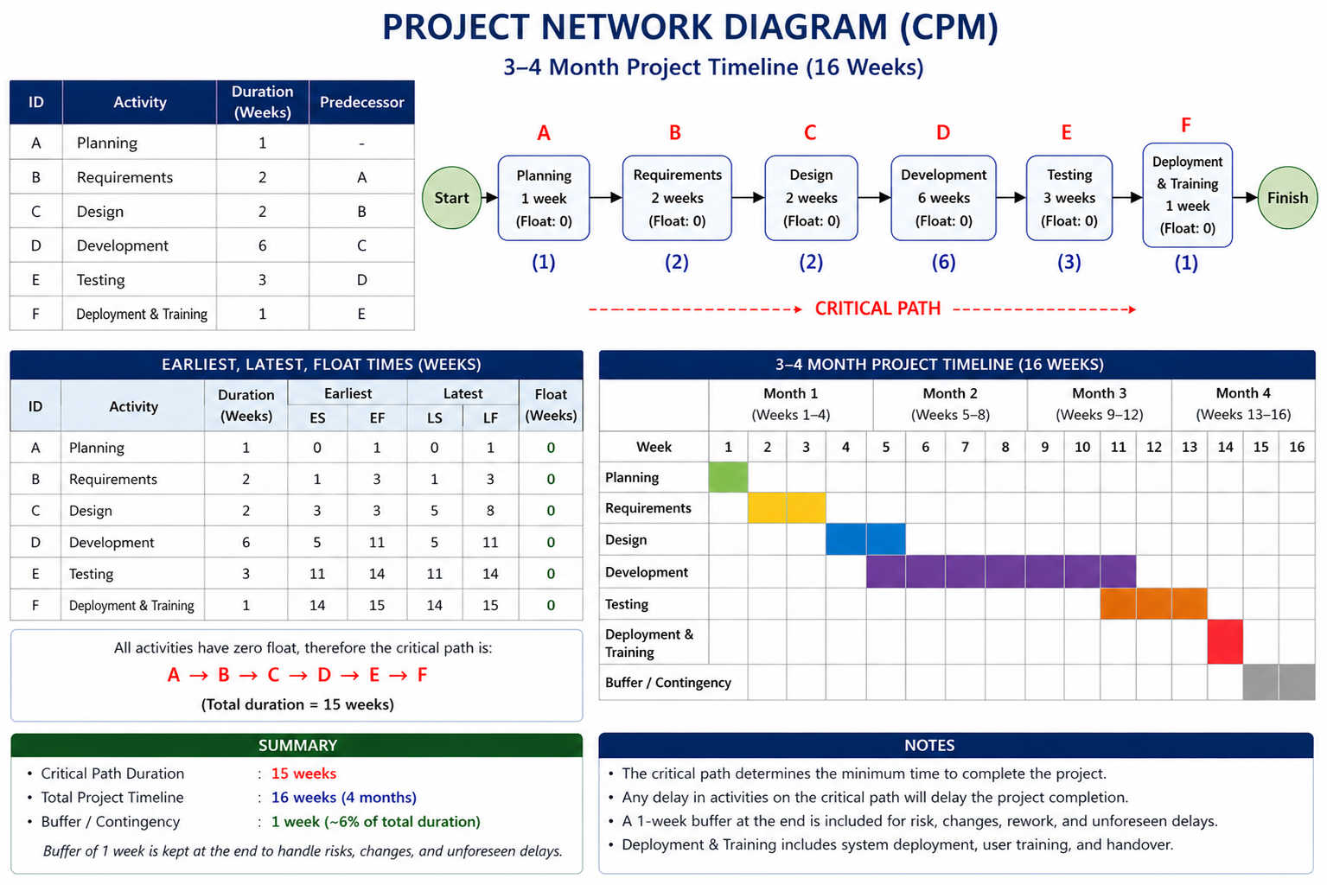

Resource Calendar
Resource | Type | Availability | Purpose
Project Manager | Human | Full project duration | Project planning, coordination, and control
Business Analyst | Human | Planning & Requirements phase | Gathering and analyzing requirements
Lead Developer | Human | Design, Development & Deployment phases | System architecture and technical supervision
Software Developer | Human | Development phase | System implementation
UI/UX Designer | Human | Design phase | Interface and user experience design
QA/Test Engineer | Human | Testing phase and Development phase | System testing and quality assurance
Laptops | Technical | Full project duration | Development, testing, and documentation
Internet Connection | Technical | Full project duration | Communication and system access
Development Software (IDE) | Technical | Design & Development phases | Coding the system
Database System | Technical | Development & Testing phases | Data storage and management
Testing Tools | Technical | Testing phase | System testing activities

Risks

Negative Risks
Risk | Response | Justification
Requirement misunderstanding | Mitigate | Regular meetings reduce errors
Development delay | Mitigate | Proper scheduling helps control time
System bugs | Mitigate | Testing reduces defects
Poor internet connection | Accept | Cannot fully control
Stakeholder unavailability | Mitigate | Early communication planning

Positive Risks
Risk | Response | Justification
Faster development | Exploit | Deliver earlier
Skilled developer performance | Enhance | Assign critical tasks
Good team collaboration | Enhance | Improves productivity
Early completion of testing | Exploit | Move to deployment faster
Availability of better tools | Enhance | Improves efficiency

